**Unit-I**

**Renewable Energy Technologies**

|  |  |  |  |  |  |
| --- | --- | --- | --- | --- | --- |
| Initial energy form | Converted energy form | | | | |
|  | Chemical | Radiant | Electrical | Mechanical | Heat |
| Nuclear |  |  |  |  | Reactor |
| Chemical |  |  | Fuel cell, battery discharge |  | Burner, boiler |
| Radiant | Photolysis |  | Photovoltaic cell |  | Absorber |
| Electrical | Electrolysis, battery charging | Lamp, laser |  | Electric motor | Resistance, heat pump |
| Mechanical |  |  | Electric generator, MHD | Turbines | Friction,  churning |
| Heat |  |  | Thermionic &  thermoelectric  generators | Thermodynamic  engines | Convector,  radiator,  heat pump |

**Heat Energy Conversion Principles:-**

**1. Thermoelectric conversion**:-

Thermoelectric generators (TEG) are compact devices that convert heat power directly into electricity due to Seebeck effect.

Seebeck effect (Fig. 1) was discovered in 1821 by Thomas Seebeck.



Heating one junction of two wires made of different metals, one noted that a voltage is obtained in the circuit:

$$V_{AB}=\left(∝_{A}-∝_{B}\right).∆T$$

where $∝_{A}$ and $∝_{B}$ are the two metals Seebeck coefficients and ΔT is the temperature difference between the two junctions.

A typical thermoelectric generator consists of two dielectric parts (usually ceramic) that serve as support for N and P type small semiconductors, electrically connected in series and thermally in parallel. Thus the thermo-element requires a source of high temperature for the hot side and cooling for the cold side (environment, ventilation, water, etc.).

As the heat moves from the hot side to the cold side, charge carriers (electrons and holes) are carried with the heat. In this way a significant potential difference is generated (Seebeck voltage)



$$U= ∝.\left(T_{h}-T_{c}\right)$$

where *U* is the generated voltage, α is the Seebeck coefficient; *T*h is the temperature of the hot source and *T*c is the temperature of the cold source.

Materials used for the thermo-elements must meet the following requirements:

• a high Seebeck coefficient α to produce a high voltage;

• thermal conductivity λ as low as possible, to reduce the heat flow that bypasses the thermo-element;

• electrical conductivity σ as high as possible to reduce the ohmic resistance and the Joule loss in the thermo-element.

**2. Thermionic emission**:-

The idea of converting heat to electricity by means of thermionic emission (TE) was first suggested by Schlichter.



Thermionic Energy Converter consists of: 1) two electrodes—an emitter, which is heated to a sufficiently high temperature to emit high-energy electrons, and a collector, which receives the emitted electrons and is operated at a significantly lower temperature, separated from one another by an inter electrode gap, which can be comprised of vacuum, vapour, or plasma; 2) an electrical load; and 3) an electrical connection. A heat source is connected to the emitter, to supply the thermal energy to the electron inside the emitter, and the collector is attached to the heat sink, to remove the heat from the collector. Initially, electrons in the outermost shell of the emitter atom are free to move around inside the surface, as they are prevented from escaping by a potential energy barrier called the work function. In order to escape, electrons must acquire a sufficient amount of energy to overcome this energy barrier. When the thermal energy from the heat source is supplied to the emitter, the kinetic energy of the electrons increases gradually, and as a sufficient amount of energy is gained, they are able to escape from the surface. These electrons then travel through the inter electrode space, and are collected into the colder collector. Eventually, a negative charge accumulates on the collector, inducing a voltage difference between these two electrodes and, by connecting them with an electrical load, the voltage difference will drive a current through the load resistance, where electric work is done. This flow of electrons, better-known as electricity, will continue as these electrons flow back to the emitter and get emitted again after gaining energy from the heat source.

**3.Thermodynamic engine(Hot Air Engine or Stirling Engine):**

Every Stirling engine has a sealed cylinder with one part hot and the other cold. The working gas inside the engine (which is often air, helium, or hydrogen) is moved by a mechanism from the hot side to the cold side. When the gas is on the hot side it expands and pushes up on a piston. When it moves back to the cold side it contracts. Properly designed Stirling engines have two power pulses per revolution, which can make them very smooth running. Two of the more common types are two piston Stirling engines and displacer-type Stirling engines. The two piston type Stirling engine has two power pistons. The displacer type Stirling engine has one power piston and a displacer piston.

**Displacer Type:**

The displacer type Stirling engine is shown here. The space below the displacer piston is continuously heated by a heat source. The space above the displacer piston is continuously cooled. The displacer piston moves the air (displaces the air) from the hot side to the cold side. The [MM-1 Coffee Cup Stirling engine](https://www.stirlingengine.com/product/21) is this type of engine. However, the MM-1 should never be heated with any heat source hotter than boiling water.

In the case of the **low-temperature difference** (LTD) stirling engine, the temperature difference between one's hand and the surrounding air can be enough to run the engine. The power piston in the displacer-type Stirling engine is tightly sealed and is controlled to move up and down as the gas inside expands. The displacer, on the other hand, is very loosely fitted so that air can move freely between the hot and cold sections of the engine as the piston moves up and down. The displacer moves up and down to cause most of the gas in the displacer cylinder to be either heated, or cooled. Note that in the following description of the cycle, the heat source at the bottom (the engine would run equally well with the heat source at the top):

1. When the displacer is near the top of the large cylinder; most of the gas is in the lower section and will be heated by the heat source and expand. This increases the pressure, which forces the piston up, powering the flywheel. The turning of the flywheel then moves the displacer down.
2. When the displacer is near the bottom of the large cylinder, most of the gas is in the upper section and will be cooled and contract, causing the pressure to decrease, which in turn moves the piston down, imparting more energy to the flywheel.

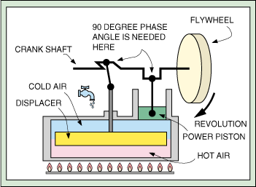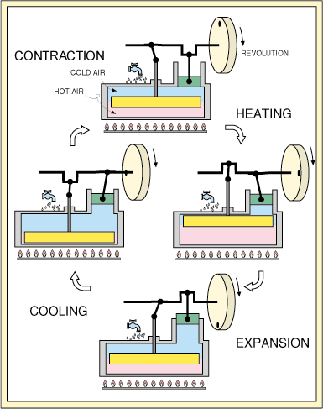

**Two Piston Type:**

The two piston type Stirling engine is shown here. The space above the hot piston is continuously heated by a heat source. The space above the cold piston is continuously cooled.

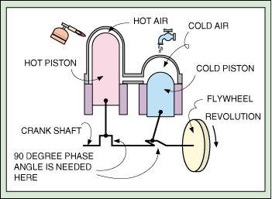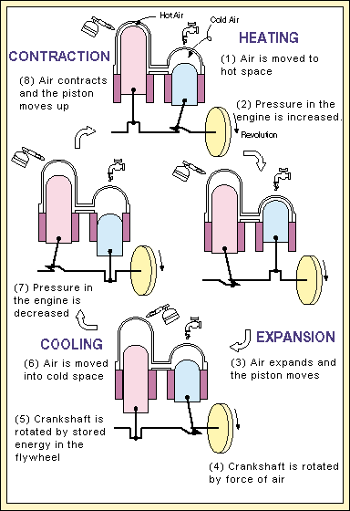

**4. Heat Pump:-**

**Construction:** A low temperature waste heat flow can be upgraded to useful high temperature heat with the use of a heat pump. Among the different types of heat pumps that have been developed, the mechanical heat pump is the most widely used. Its operating principle is based on compression and expansion of a working fluid, or so called 'refrigerant'. A heat pump has four main components: evaporator, compressor, condenser and expansion device. The refrigerant is the working fluid that passes through all these components. In the evaporator heat is extracted from a waste heat source. In the condenser this heat is delivered to the consumer at a higher temperature level. Electric energy is required to drive the compressor and this energy is added to the heat that is available in the condenser. The efficiency of the heat pump is denoted by its [COP (coefficient of performance)](http://industrialheatpumps.nl/en/how_it_works/cop_heat_pump/), defined as the ratio of total heat delivered by the heat pump to the amount of electricity needed to drive the heat pump.

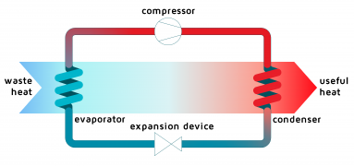

**Operating Principle:** The operating principle of a heat pump is based on the physical property that the boiling point of a fluid increases with pressure. By lowering pressure, a medium can be evaporated at low temperatures while an increase of pressure will lead to a high boiling point. The graph below shows this principle. The black line shows the relation between pressure and boiling point of, in this case, Ammonia. At low pressure and temperature Ammonia is evaporated in the evaporator. The energy needed for this is provided by a waste-heat flow. The compressor increases the pressure of the Ammonia vapour. The vapour is then condensed at high pressure and temperature inside the condenser. During the condensation of Ammonia, heat is released: a useful source of energy. The liquid Ammonia is transported to the expansion device that lowers pressure. The low temperature, low pressure Ammonia flows to the evaporator: the starting point of yet another cycle

